AL-FARABI KAZAKH NATIONAL UNIVERSITY | 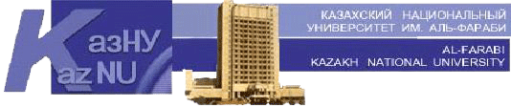

Faculty of Philology and World Languages

«Confirmed» by
Dean of the faculty
______________ B.O. Dzholdasbekova
«_______»____________202__

Methodical recommendations for the preparation of EMCD:
“Guidelines for the organization of the IWS

Discipline Scientific writing
Course/Specialty 2 course. Foreign language: two foreign languages
Semester 4

№ | Tasks for the IWS | Form of execution | Deadline (week)
1 | Introduction with research article | PDF or word format of the article | 3rd week
2 | Analyses of the article written by IMRAD structure | PDF or word format of the article | 4th week
3 | Analyses of the article. Working with the Introduction part of the article | PDF or word format of the article | 5th week
4 | Analyses of the article . Considering Methods part of the article | PDF or word format of the article | 8th week
5 | Analyses of the article . Considering Results part of the article | PDF or word format of the article | 9th week
6 | Analyses of the article . Considering Discussion part of the article | PDF or word format of the article | 10th week

Methodological recommendations

№ | Themes of the IWS | Methodological recommendations | Score
1 | Article chosen by students | Reading and analyzing | 5
2 | Article chosen by students | Reading and analyzing | 5
3 | Article chosen by students | Reading and analyzing | 5
4 | Article chosen by students | Reading and analyzing | 5
5 | Article chosen by students | Reading and analyzing | 5
6 | Article chosen by students | Reading and analyzing | 5

Considered and recommended at the meeting of the Department of General Linguistics and European Languages
Protocol № __, ________ __, 20__

Head of the department _____________________ G.B. Madiyeva

Recommended by methodical bureau of the faculty
Protocol № __, ________ __, 20__

Chairman ________________________ L.V. Ekshembeeva

